**DAILY ASSESSMENT**

|  |  |  |  |
| --- | --- | --- | --- |
| **Date:** | **16/06/2020** | **Name:** | **Dhavala** |
| **Course:** | **Statistical Learning** | **USN:** | **4AL17EC027** |
| **Topic:** | * **Case Study on statistics & probability theory** * **Solution for case study** | **Semester & Section:** | **6TH SEM & A Section** |
| **Github Repository:** | **Dhavala27** |  |  |

|  |
| --- |
| **SESSION DETAILS** |
|  |

|  |
| --- |
| **Report** |

|  |  |  |  |
| --- | --- | --- | --- |
| **Date:** | **16/06/2020** | **Name:** | **Dhavala** |
| **Course:** | **Future Ahead for Electronics Engineers** | **USN:** | **4AL17EC027** |
| **Topic:** | **An Overview of Avionics in Electronics Industry** | **Semester & Section:** | **6TH SEM & A Section** |
| **Github Repository:** | **Dhavala27** |  |  |

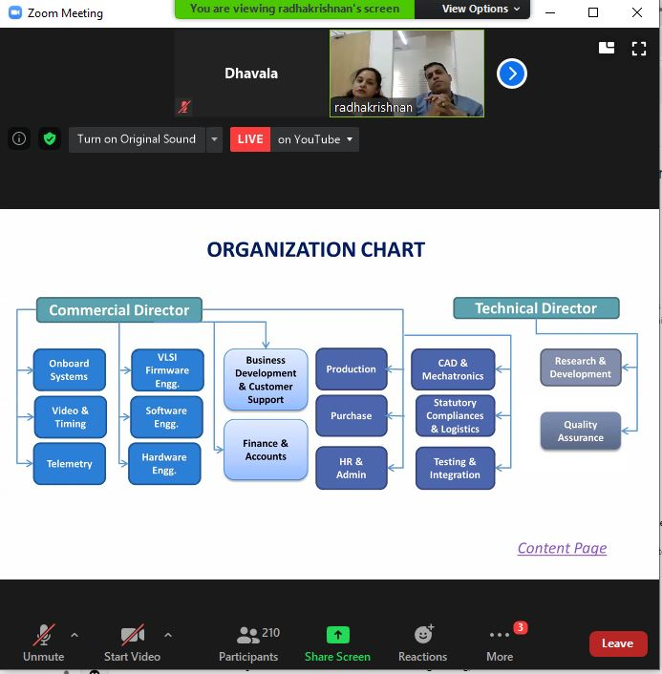

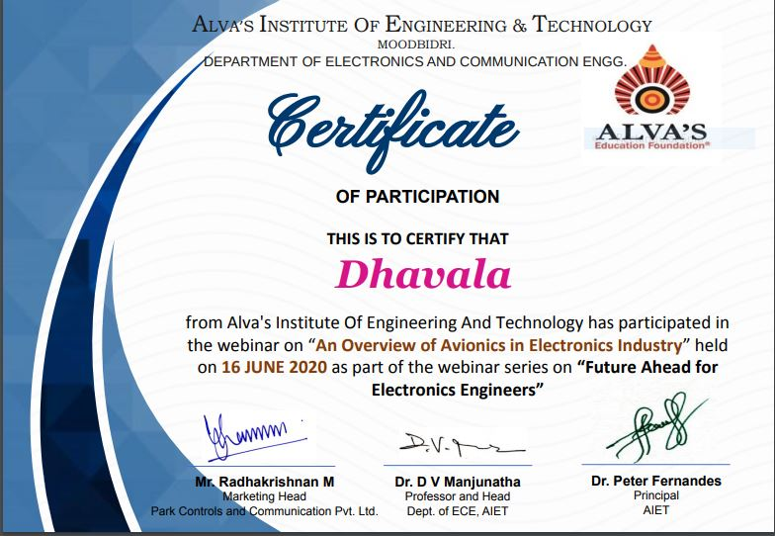

|  |  |  |  |
| --- | --- | --- | --- |
| **Date:** | **16/06/2020** | **Name:** | **Dhavala** |
| **Course:** | **Statistical Learning** | **USN:** | **4AL17EC027** |
| **Topic:** | * **Introduction to Probability** | **Semester & Section:** | **6TH SEM & A Section** |
| **Github Repository:** | **Dhavala27** |  |  |

|  |
| --- |
| **SESSION DETAILS** |
|  |

|  |
| --- |
| **Report** |